Understanding the New Portal

Jersey Central Power & Light



Contents

Program Ally/Distributor Log in 2

Customer Log in 2

Starting an Application and Validating the Site Information 3

JCPL Portal Dashboard 3

Accessing the Portal 3

Dashboard Tab Definitions 5

OLA Status 5

Project Status 5

Action Required 5

Payment 5

What Status will be displayed on the Portal? 5

What can I do on each Tab? 6

• View the data: 6

• Copy the data: 6

• Export the data: 6

• Search the data: 6

Action Required Tab 6

How to see the Action Required? 6

Who is notified of the Action Required? 6

What steps are taken to complete the Action Required? 6

To Add Missing Documents as Requested 6

What can I do from this tab? 7

What is the workflow from this tab? 7

Project Status Tab 7

What can I do from this tab? 7

What is the workflow from this tab? 7

All Applications submitted must include the workbook to calculate incentive total. 7

How do the incentive details get on the Project? 7

Where to access the workbook? 8

Payment Tab 8

Payment Status Includes: 8

# Program Ally/Distributor Log in

Go to the main website at <https://bizsolutions.energysavenj.com/>

* From the Top Menu, go to Application Portal>Program Ally/Distributor Log-in

* The log-in page will expect you to use your username and password

**Best Practices**

* Be sure to always use the most current version of the workbook that is required to be submitted with all application submissions. On the homepage there is a link for you to access the workbook for use.
* Go to the Left side menu from the Portal logged in page to navigate to other areas.
* Click on the menu item from the left side menu, Create New Application or the button in the center of the page to start a new application.

# Customer Log in

Go to the main website at <https://bizsolutions.energysavenj.com/>

* From the Top Menu, go to Application Portal>Customer Applications

* On the Customer application page, the customer will enter their site details to validate they are a JCPL utility customer. The customer details can be found on the JCPL utility bill.
* The customer will be able to view all applications submitted for their specific site address. Even if a Program Ally submitted the application on your behalf, you can view this from the customer dashboard after validating.
* Click on the menu item from the left side menu, Create New Application.

# Starting an Application and Validating the Site Information

As a Program Ally or Distributor, you start an application by using the left side menu.

* Click on Create New Application.
* Enter Account Number and Account Name, it must match the bill exactly.
* Choose the application type that you are submitting the application for.
* The workbook link will be provided on screen for ease of access.
* Then you click next, and you will begin the application.

Note: It is important to ALWAYS use the most recent version of the workbook so not to delay the processing of your application. Always download the workbook before each submission.

# JCPL Portal Dashboard

When applying through the JCPL Portal as a Program Ally, a Distributor or a Customer for a qualified Incentive everyone will have access to the portal dashboard to view their applications.

The improved dashboard allows users to view status of these applications as they are approved, converted to an official project and are processed through the steps to get to pay out of the calculated incentive.

Accessing the Portal

<https://jcplcapturesportal.com/Account/Login>

Once you are logged into the portal as a Program Ally or a Distributor, or once you have validated your site information as a customer you will have access to the side menu that will have the links you need, or there are buttons in the middle of the page that also link to the dashboard.

You can access the side menu by clicking on the black box with three white lines located in the upper left corner.

If you need credentials for the portal, please contact the program team.

Clicking on Applications Dashboard from this menu will bring you to the landing page which defaults to the ‘Project Status View’.

The Project Status View is likely the tab users will spend the most time in so we have placed the Program Ally and Distributors Company statistics at the top of this page, this will improve tracking of the number of projects submitted, total incentives received and how much energy savings the company is getting credit for as the projects are completed.

Customers viewing the dashboard will not see statistics.

The portal will display four tabs that the end users have access to, that will keep them informed on the status of their applications.

Above is an example of the view you see for the tabs we will review throughout this document.

## 

## Dashboard Tab Definitions

Let’s review the definitions of the tabs inside the dashboard for full understanding.

|  |  |
| --- | --- |
| OLA Status | This Dashboard Tab displays all the Applications pending submission, Pending Signature or Pending Project Creation. It is saved to the Dashboard once it passes the first page of the application, which is the date created. This allows the OLA ID to be displayed. |
| Project Status | This Dashboard Tab displays all projects in progress. Once the project is created in the administrative system it is removed from the OLA Status Tab. It will follow along the lifecycle of the project approvals, inspections, offer and installation tasks through to Payment by updating the status field for each project so that the applicant can follow along. |
| Action Required | During the Project Lifecycle anytime there is an action required by the applicant an indicator will be added by the Case Manager inside the administrative system that will post the specific project details inside the Action Required Tab, it will remain on the Project Status Tab as well with a status of Action Required. The details around what actions are needed will be noted and displayed for the applicant to act on them. They will have the ability to upload missing docs from this tab. |
| Payment | Once the project has received all final approvals it will move into the Payment Authorized step, and this Payment tab will show the status through to complete, once it is completed it will come off the Project Status tab and stay in this Payment tab for 180 days, then it is archived and cannot be accessed unless requested. |

## What Status will be displayed on the Portal?

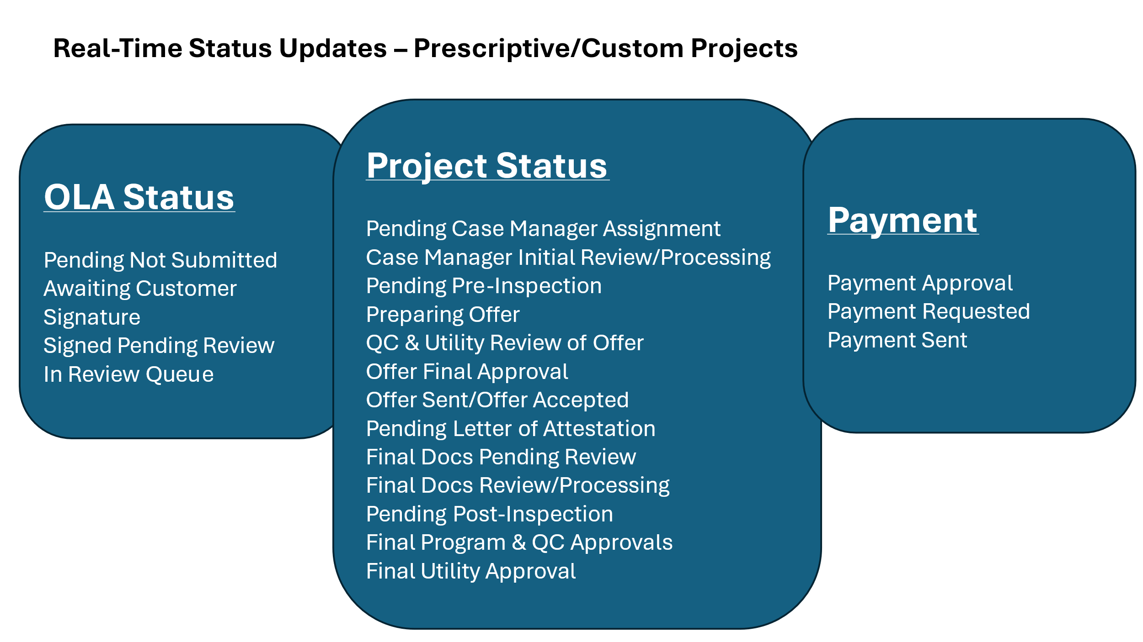

Each tab has columns of data that are specific to the tab you are in. The details within these columns should provide you with all the information you need to understand the status of the project.

## What can I do on each Tab?

### View the data: Each tab will have columns that will display the needed details to understand the status of each Application or Project.

* Copy the data: Simply click copy, open excel and paste. It will allow you to see the full grid of details for you to manipulate the data as needed.
* Export the data: Simply click export, it will download an excel version right to your computer’s download folder.
* Search the data: Add a specific name or address and click search to find specific details within the grid.

The tab on this portal dashboard that is most critical will be the “Action Required” Tab.

## Action Required Tab

This tab will allow the user to view any actions requested to continue processing the specified project. Typically, the project cannot move forward without this action completed.

|  |  |
| --- | --- |
| How to see the Action Required? | Go to the Action Required Tab, Click on Message and/or click on the View Application button |
| Who is notified of the Action Required? | The Prescriptive customer and the PA will receive an email that action is required. An email will only be sent to the PA for Midstream projects. |
| What steps are taken to complete the Action Required? | The applicant must complete the action required of them and the case manager will get an email to clear the action and continue processing |

The Program Ally or customer that submitted the application will receive an email letting them know an action is required.

As an action request is added on a specific project, the customer and the identified Program Ally or the Distributor that submitted the application will get an email that an action is required. There will be three reminder emails and then the project may be placed on hold until the required documents are received.

This DOES stop the process of the application until all required documents or data are provided for the project to move on.

## To Add Missing Documents as Requested

Click on the View Application from the Action Request Tab. There will be a message shown from the Case Manager assigned to the project. Below there will be the details of what documents are missing and require action.

Upload them using the area provided. Once complete, an email will be sent to the case manager that the documents are uploaded, and they can continue to process the application. Once the new information is reviewed, the case manager will resolve the action, and it will disappear from the dashboard action tab.

This tab will allow the user to view all the pending applications. A pending application is created in the administrative system once the applicant passes the first page of the application, and an OLA ID is created. This is an application that has not yet been converted to a project.

### What can I do from this tab?

* Resume an application: Pick up where the applicant left off so that they can complete the necessary details and submit the application to begin the process.
  + IF the ‘Saved for Later’ feature is used, this is where the applicant should go to resume the application.
  + IF the user is somehow disconnected from the system and needs to resume the application that they started this is where they should go.
* View an application: View one that has been submitted but is not yet approved to be converted to a project.

### What is the workflow from this tab?

* The applications will disappear from this tab once the project is created in the administrative system and then be displayed on the Project Status tab.

## Project Status Tab

This tab will allow the user to view all the pending projects. The administrators validate the details that are submitted on the OLA and confirm a workbook has been attached.

The project will remain on this project tab throughout the review process keeping the status updated for real-time review. Once the offer is accepted by the customer and approved for payment the project will be removed from the project status tab and only appear in the ‘Payment Tab.’

### What can I do from this tab?

* View specific status on the pending application: The Status column will be updated as the actions by the program team are done inside the administrative system.
  + Pending Not Submitted
  + Awaiting Customer Signature
  + Signed Pending Review
  + Pending Program Team Assignment
* View the details submitted with the application

### What is the workflow from this tab?

* It will remain on this tab until the offer is accepted, or the offer is approved for payment.
* Then it goes onto the payment tab in the portal to show the status on payment delivery.

## All Applications submitted must include the workbook to calculate incentive total.

### How do the incentive details get on the Project?

The calculations for the incentive come from the attached workbook. The most current version of the workbook should be always used to ensure proper calculations. This workbook can be downloaded from several areas of the portal. The workbook should be downloaded each time an application is submitted so that we are sure to be able to process properly.

### 

### Where to access the workbook?

Workbook Link for Lighting = <https://bizsolutions.energysavenj.com/wp-content/uploads/2023/08/JCPL-Lighting-Workbook.xlsx>

Workbook Link for Non-Lighting = <https://bizsolutions.energysavenj.com/wp-content/uploads/2025/03/JCPL_NonLighting-Workbook_FINAL.xlsx>

Workbook Guide = <https://bizsolutions.energysavenj.com/wp-content/uploads/2023/08/JCPL-Lighting-Workbook-Process.pdf>

## Payment Tab

This tab will be used when the project has all approvals completed. The project will be removed from the Project Status Tab upon final approval and be shown on the Payment Tab as it goes through the Payment Process.

Payment Status Includes:

|  |  |
| --- | --- |
| Payment Approved | Confirmed all approvals obtained |
| Payment Requested | Payment Requested to be added to the Batch for processing |
| Payment Sent | Payment Mailed to the Payee information provided on the project |
| Once sent it can take 7 to 10 days for delivery | |

If you have additional questions, contact your case manager or program team.

For more information, visit energysaveNJ.com or contact us at 866-527-5249 or [energysaveNJ@trccompanies.com.](mailto:energysaveNJ@trccompanies.com.)

*For commercial, industrial efficiency programs, please visit* [*https://bizsolutions.energysavenj.com/*](https://bizsolutions.energysavenj.com/)*. First Energy's New Jersey Utility, their parent subsidiaries, employees, affiliates, and agents assume no responsibility for the performance of the equipment or equipment warranty, the quality of the work, labor and/or materials supplied, and/or the acts or omissions of any Program Ally.*

*Disclaimer: FirstEnergy's New Jersey utility provides a Program Ally listing as a courtesy to customers, but does not approve, recommend, endorse or otherwise promote any Program Ally, vendor, manufacturer, distributor, contractor, or any other provider of products and services that could potentially qualify for FirstEnergy's Energy Efficiency programs. FirstEnergy's utilities and TRC provide this list of independent contractors as a convenience for customers seeking assistance with energy savings-related products and services. Participating contractors are independent and are not affiliated with FirstEnergy, its utilities, or TRC. Customers are solely responsible for dealing directly with contractors in all aspects of their interaction including but not limited to the definition of the scope of work, costs, contractual terms and conditions, and the level of accuracy required when estimating energy savings.*

*By participating in these energy efficiency and peak demand reduction programs, customers agree to allow their utility to retain ownership of all Capacity Rights which refers to the demand reduction associated with any energy efficiency and peak demand reduction measure for which incentives were provided by the Company. Your utility will aggregate these energy efficiency demand reduction attributes into the PJM capacity market with proceeds being used to offset the program costs.*

*Costs of these programs may be recovered through customer rates in accordance with New Jersey law. For a complete list of commercial, industrial, residential, and low-income energy efficiency programs, please visit energysaveNJ.com.*

*JCP&L’s energy efficiency programs are administered by TRC, a third-party implementation specialist that helps homes and businesses save energy.*